Title
Smart Grid Energy Distribution Analysis Using the Master Theorem
Aim
To solve the recurrence relation
$$T\left(n\right)=4T\left(n/2\right)+n\log{n}$$
using the Master Theorem and determine its complexity.
Algorithm
- Read the input size $n$.
- If $n=1$, return the base value.
- Divide the problem into four equal subproblems.
- Perform merge work of $n\log{n}$.
- Display the recurrence value, recursion depth, execution time, time complexity, and space complexity.
Applying the Master Theorem
General form: $T\left(n\right)=aT\left(n/b\right)+f\left(n\right)$
Parameters:
- $a=4$
- $b=2$
- $f\left(n\right)=n\log{n}$
Compute: $n^{\log_{b}a}=n^{\log_{2}4}=n^{2}$
Since $n\log{n}=O\left(n^{2-ε}\right)$
the recurrence satisfies Master Theorem Case 1.
Therefore, $T\left(n\right)=Θ\left(n^{2}\right)$

Complexity Analysis
Parameter | Value
Technique | Divide and Conquer
Solving Method | Master Theorem
Time Complexity | Θ(n²)
Space Complexity | Θ(log₂n)
Recursion Depth | log₂n

Performance Analysis
Input (n) | Recursion Depth | Time Complexity | Space Complexity
2 | 1 | Θ(n²) | Θ(log₂n)
4 | 2 | Θ(n²) | Θ(log₂n)
8 | 3 | Θ(n²) | Θ(log₂n)
16 | 4 | Θ(n²) | Θ(log₂n)
32 | 5 | Θ(n²) | Θ(log₂n)

Input: 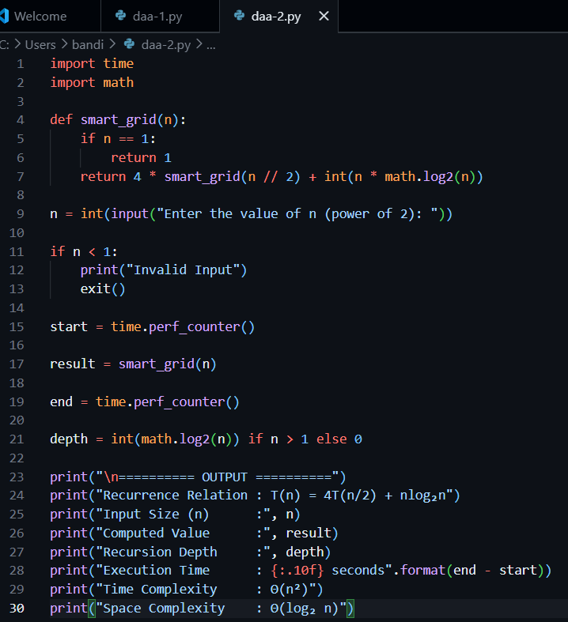

Output:
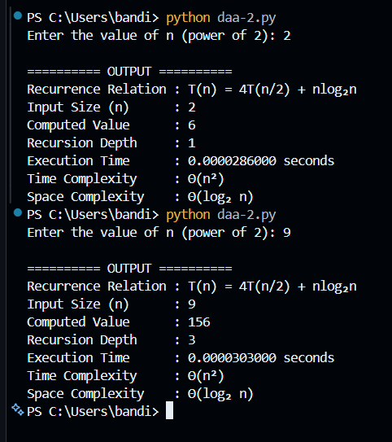
Applications
- Smart Power Grid Management
- Energy Distribution Systems
- Electrical Network Optimization
- Load Balancing Algorithms
Result
Using the Master Theorem, the recurrence $T\left(n\right)=4T\left(n/2\right)+n\log{n}$belongs to Case 1, resulting in a time complexity of $Θ\left(n^{2}\right)$and a space complexity of $Θ\left(\log_{2}n\right)$. These are the standard DAA results for this recurrence.

